CVE-2018-8174 Windows VBScript Engine Remote Code Execution Vulnerability

Descriptions:

Due to the code execution vulnerability in the VBScript script execution engine (vbscript.dll), an attacker can embed malicious VBScript into Office files or websites. Once the user accidentally clicks, a remote attacker can obtain the current user permission to execute the malicious code in the script; the vulnerability affects the latest version of the IE browser and applications that use the IE kernel.

Users may be attacked when browsing the web or opening Office documents, and eventually, hackers implanted backdoor Trojans to take complete control of the computer. In a web-based attack scenario, an attacker could exploit the vulnerability of a specific website through Internet Explorer and then convince the user to view the website. An attacker could also embed ActiveX controls marked as "safe to initialize" in an application or Microsoft Office document that hosts the IE rendering engine. Attackers can also use compromised websites and websites that accept or host user-provided content or advertisements. These websites could contain specially crafted content that could exploit this vulnerability.

The chart below shows the CVEs and number of URLs seen leveraging the respective CVEs at 2018 Q2.

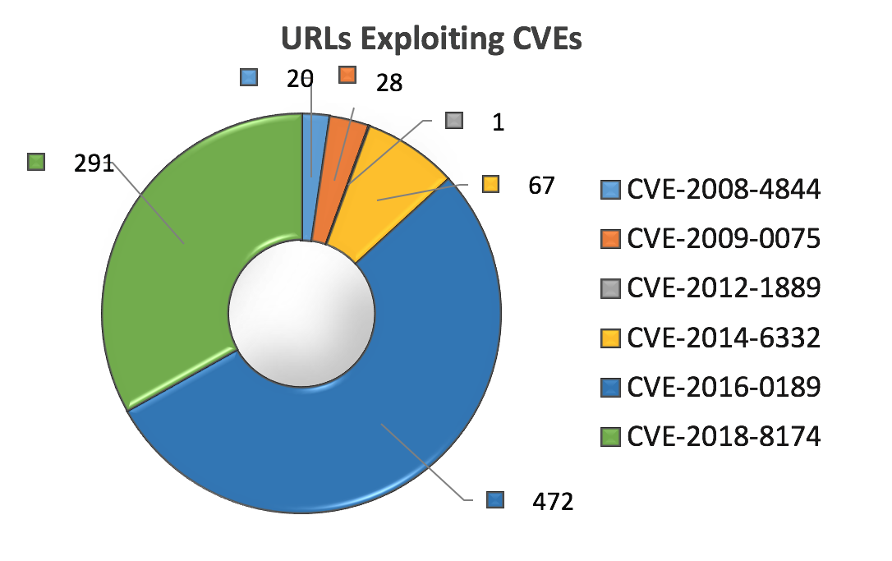

CVE-2018-8174 is a code execution vulnerability in the Microsoft VBScript engine detected as a zero-day attack and patched by Microsoft in [May 2018](https://portal.msrc.microsoft.com/en-US/security-guidance/advisory/CVE-2018-8174). This vulnerability was not publicly known until the second quarter, and we can see it was quickly used by attackers taking advantage of it, making it number two on our list in the second quarter, exploited by 291 malicious URLs.

What is the VBScript Engine?

Microsoft Internet Explorer (IE) is a web browser included with Microsoft's Windows operating system. VBScript Engine is one of the VBScript scripting language engines. It is a lightweight interpreted language in the Microsoft environment. It uses COM components, WMI, WSH, ADSI to access elements in the system and manage the system. At the same time, it is the default programming language for asp dynamic web pages. With asp built-in objects and ADO objects, users can quickly master the asp dynamic web page development technology for accessing databases.

What is VBScript used for?

* VBScript is used to give functionality and interaction to web pages.
* VBScript can be used for **client-side** scripting.
* If VBS is used for client side scripting, **only Internet Explorer** can interpret it (down side). VBScript is a Microsoft technology that requires Microsoft's IE.
* VBS can also be used for **server-side** scripting. This requires the use of a Microsoft web server such as Personal Web Server (PWS), or Internet Information Server (IIS) and a packaging such as Active Server Pages (ASP).

CVSS Scores:

| CVE | CVE-2018-8174 |
| --- | --- |
| Products Affected by CVE | Microsoft Windows |
| CVSS Score (NVD) | 7.5 |
| Examples of Threat Actors | Silent Group, Dark Hotel APT |
| Attack Vector | Network |
| Attack Complexity | High |
| User Interaction | Required |
| Confidentiality | High |
| Integrity | High |
| Availability | High |
| Privileges Required | None |
| Remediation Level | Official Fix |
| Report Confidence | Confirmed |

What could this vulnerability affect?

The vulnerability could corrupt memory, allowing an attacker to execute arbitrary code in the current user's context. An attacker who successfully exploited this vulnerability could gain the same user rights as the current user. If the current user is logged on with administrative user rights, an attacker who successfully exploited the vulnerability could take control of an affected system. An attacker could then install programs, view, change, delete data, or create new accounts with full user rights.

In a web-based attack scenario, an attacker could host a specially crafted website designed to exploit the vulnerability through Internet Explorer and then convince users to view the website. An attacker could also embed ActiveX controls marked "safe for initialization" in an application or Microsoft Office document that hosts the IE rendering engine. Attackers can also use compromised websites and websites that accept or host user-provided content or advertisements. These websites could contain specially crafted content that could exploit this vulnerability.

Demo:

1. Download Kali Virtual Machine where it has built-in metasploit-framework that we are going to use.
2. Setup in the VirtualBox.
3. Download the exploit example.
4. Copied to the corresponding exploit module directory. (Notice: The original file format with “-” will reporting error change it to “_” instead.

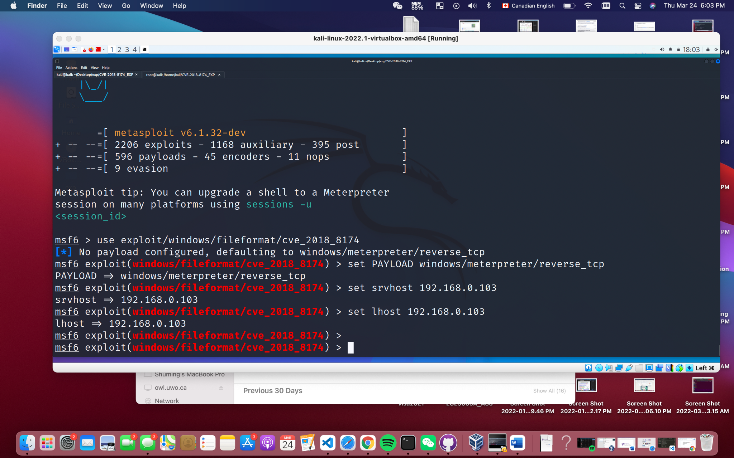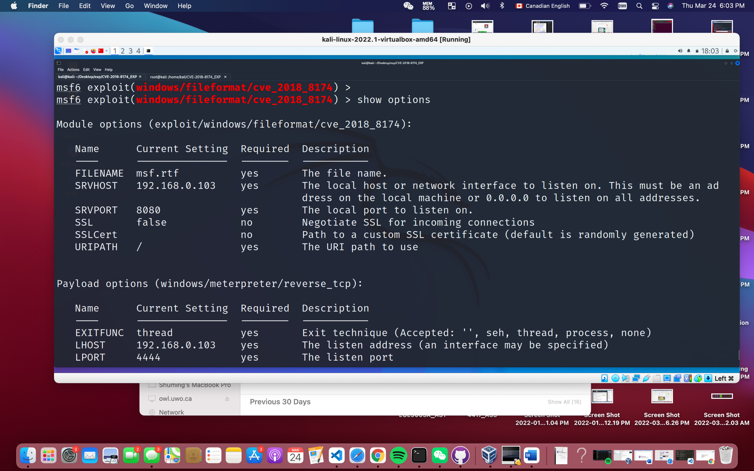

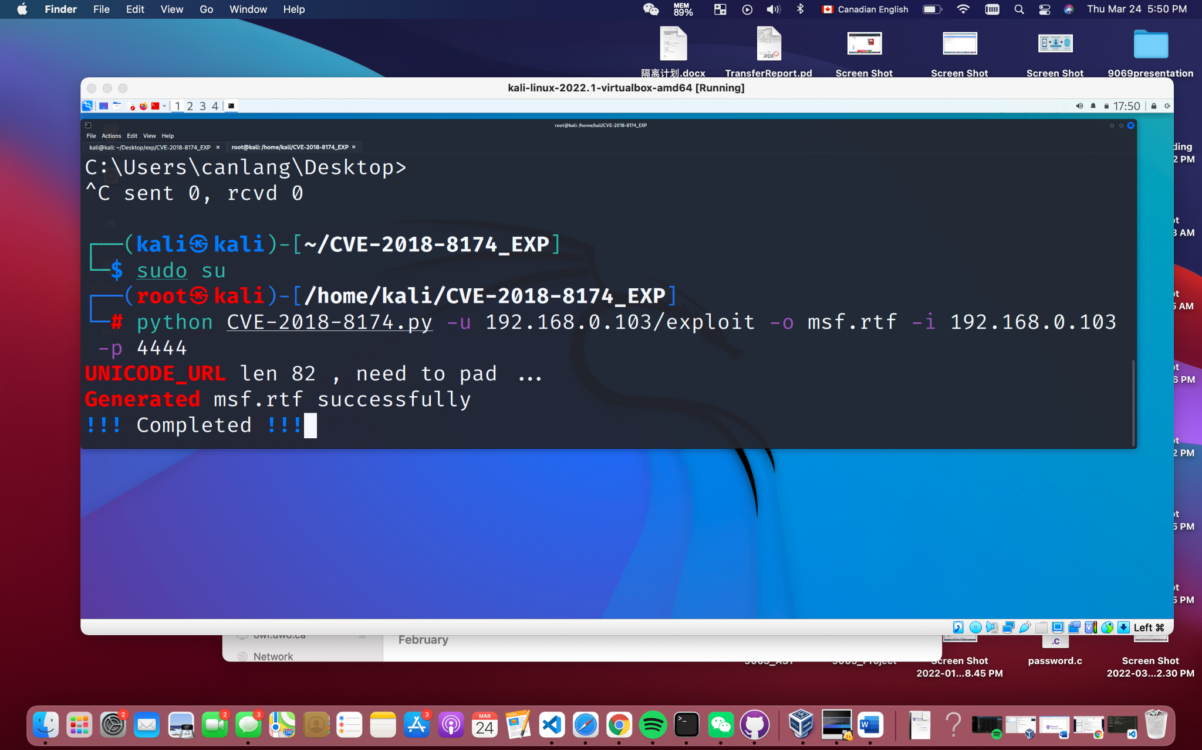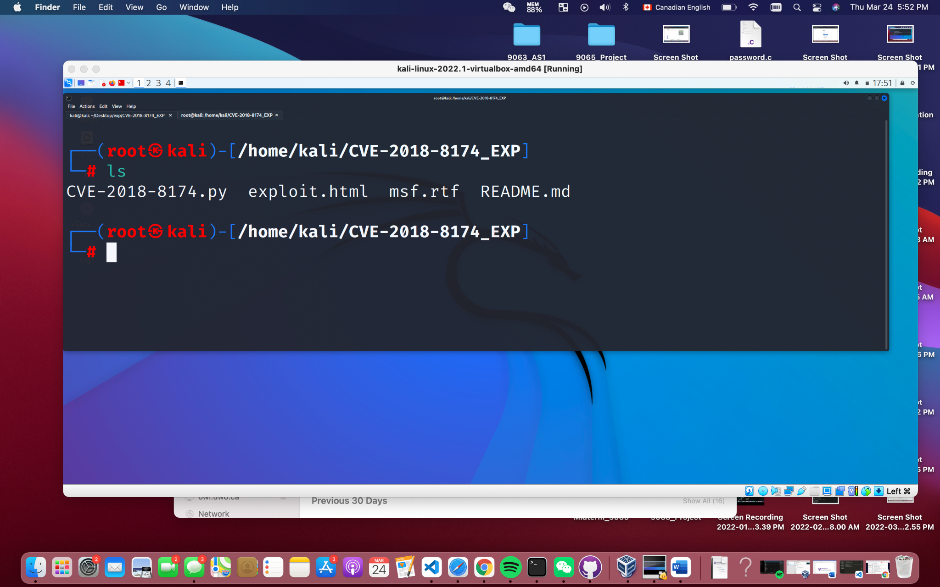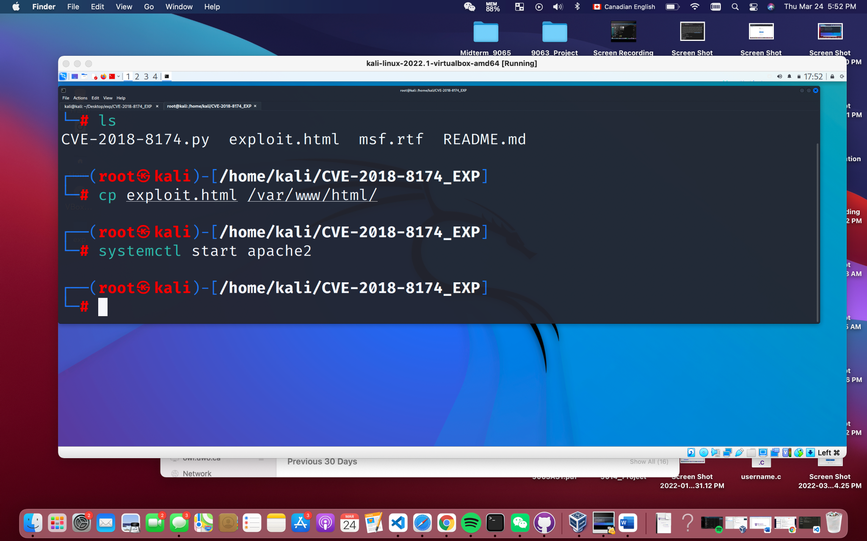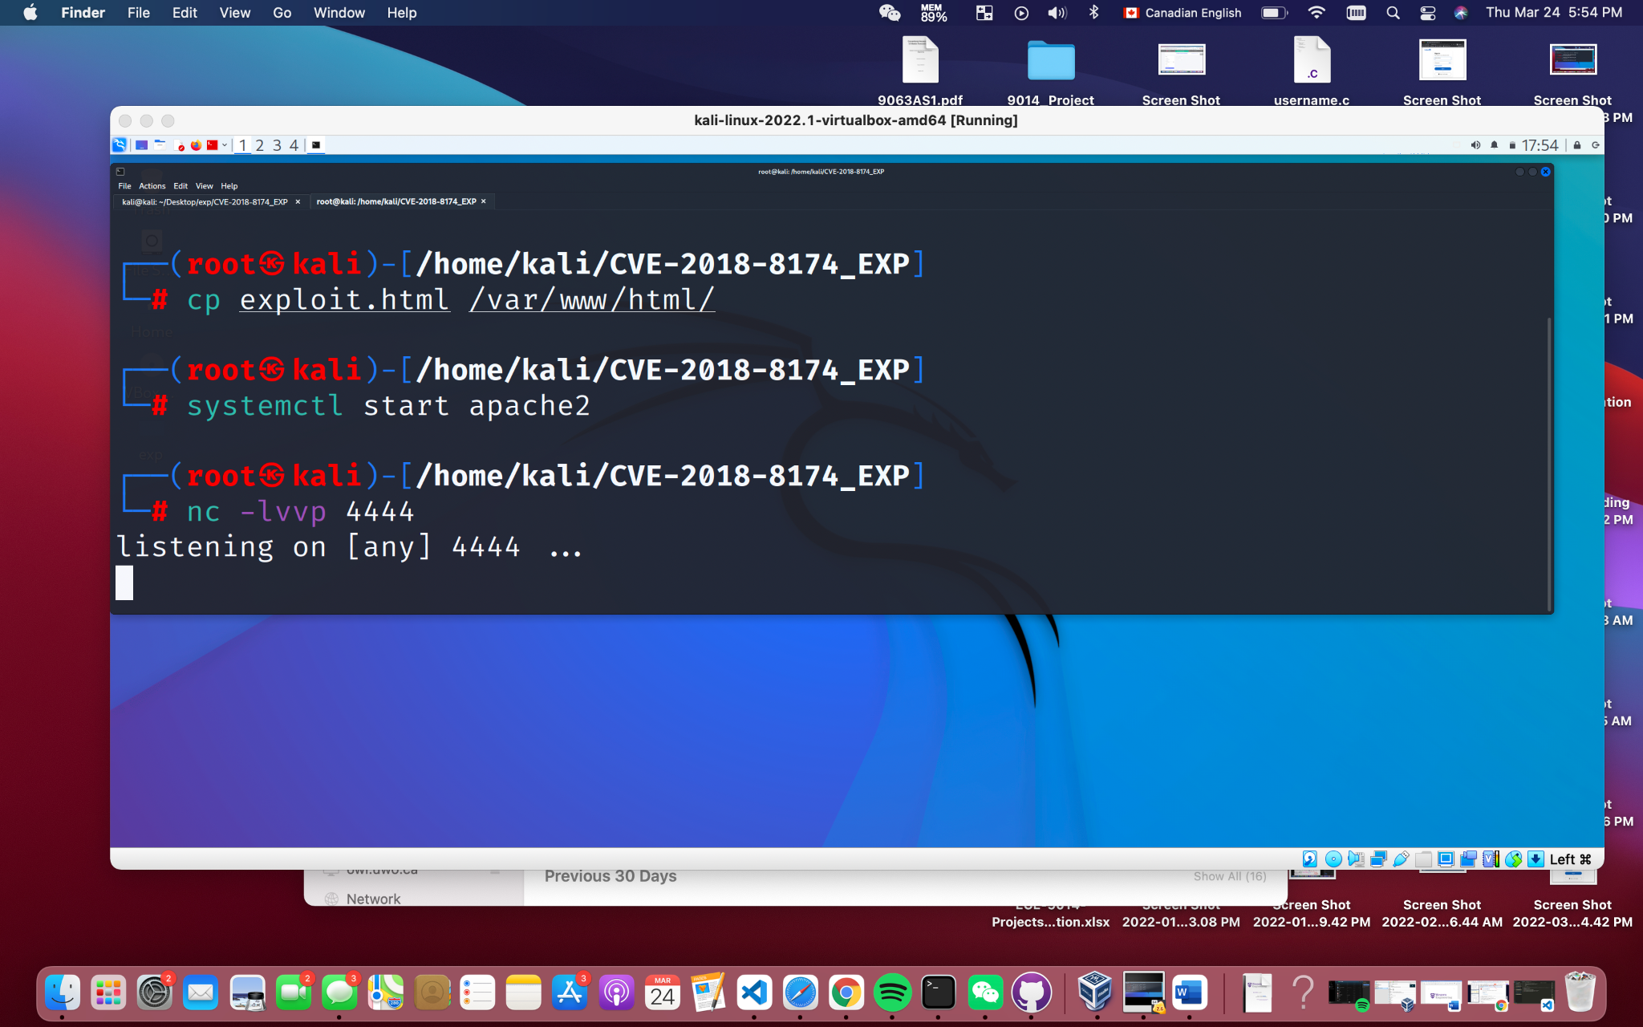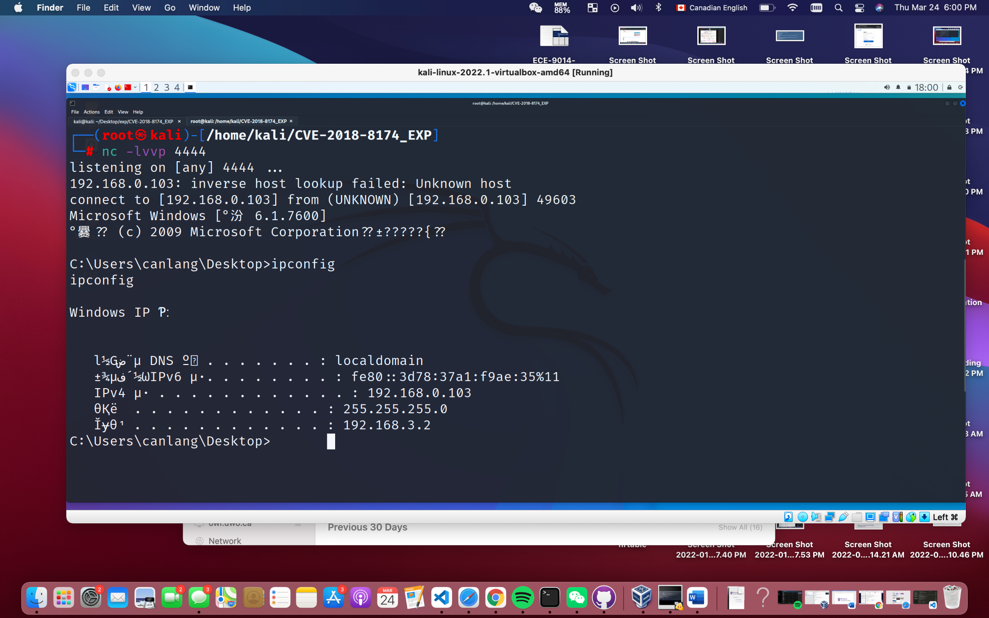

Reference:

[https://www.cse.fau.edu/~roy/cop4020.01c/VBScript.htm](https://www.cse.fau.edu/~roy/cop4020.01c/VBScript.html)

<https://www.rapid7.com/db/vulnerabilities/msft-cve-2018-8174/>

<https://blog.qualys.com/product-tech/2019/12/27/top-19-vulnerability-cves-in-santas-dashboard-tracking>

<https://unit42.paloaltonetworks.com/unit42-web-based-threats-2018-q2-u-s-remains-1-malicious-web-addresses-china-falls-2-7/>

<https://www.tutorialspoint.com/vbscript/vbscript_overview.htm>